Trade-Based Money Laundering

TraCCC will be hosting a full day conference on the very serious problem of trade-based money laundering.

Panels with specialists from the financial community, government, ACAMS, think-tanks, NGOs and academics will discuss this phenomenon which is still extensively used to move large amounts of illicit funds tied to corruption, illicit trade, transnational crime and terrorism. Much of the money movement of the Panama Papers and the Troika laundromat was tied to trade-based money laundering. This conference will explore the complex ways in which this presently under-regulated form of money laundering operates and discuss strategies to address it.

Date: September 18, 2019, 8:00 am - 5:00 pm
Location: GMU Van Metre Hall, 3351 Fairfax Drive, Arlington, VA

RSVP: click here or email traccc@gmu.edu

Info: traccc.gmu.edu/events/upcoming-events/

Lunch will be provided

Reception to follow from 5:00 – 7:00 pm

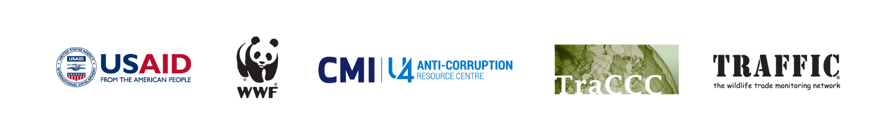
This event is made possible by the generous support of the American people through the United States Agency for International Development (USAID). The contents are the responsibility of TraCCC and do not necessarily reflect the views of USAID, the United States Government, or individual TNRC consortium members.

Trade Based Money Laundering: Agenda

8:00am | Registration
8:45am  -  8:55am | Welcome and intros:  Louise Shelley, Director, TraCCC  Dennis Dunleavy
9:00am  -  9:55am | What is TBML? Part 1: Let’s be clear  Charles Davidson, GMU, (Moderator)  Raymond Baker, Global Financial Integrity  Stacey Facter, BAFT  John Cassara, Global Financial Integrity  David Johnson, C4ADS
10:00am  -  10:55pm | TBML Impacts  Louise Shelley, GMU-TraCCC (Moderator)  David Luna, Former Senior Director, INL  Jodi Vittori, CEIP  Tom Cardamone, Global Financial Integrity
11:15am  -  12:30pm | TBML from the Perspective of Financial Institutions and Business  Elise Bean (Moderator)  Amy Hull, Standard Charter  Les Joseph, Wells Fargo  Bryan Earl, HSBC  Brett Barrett, CaseWare
12:35pm  -  1:40pm | LUNCH BREAK  Introduction of speaker  Clay R. Fuller, AEI; The Honorable Thomas M. Davis, Rector, George Mason University  Luncheon Speaker  The Honorable Senator Bill Cassidy, M.D., Louisiana
1:45pm  -  2:45pm | TBML from the Perspective of the Government  Dennis Dunleavy (Moderator)  Brendan McMurrough, British Embassy  Raul Aguilar, ICE/HSI  Sharon Melzer, FINCEN
3:00pm  -  4:15pm | Breakout Sessions  - Legislative Strategies—Johnathan Rusch, Georgetown (moderator), Danielle Lindholm, House Financial Services Committee, Paul Massaro, Committee on Security and Cooperation in Europe (off the record)  - Environmental Strategies – Methods to identify TBML in wildlife, timber and fish trade  Channing Mavrellis, Global Financial Integrity  Michele Kuruc, WWF  Ben Freitas, WWF  - Private Sector Strategies, Herman Albamonte, PMI  - How Do We Measure TBML?  Kateryna Boguslavska, Basel Institute of Governance
4:15pm  -  4:45pm | Summarizing the results of Break Out Sessions
4:45pm  -  5:00pm | General Session Concluding Remarks  Louise Shelley (GMU-TraCCC)
5:00pm  -  7:00pm | Networking Reception

